Brainwriting

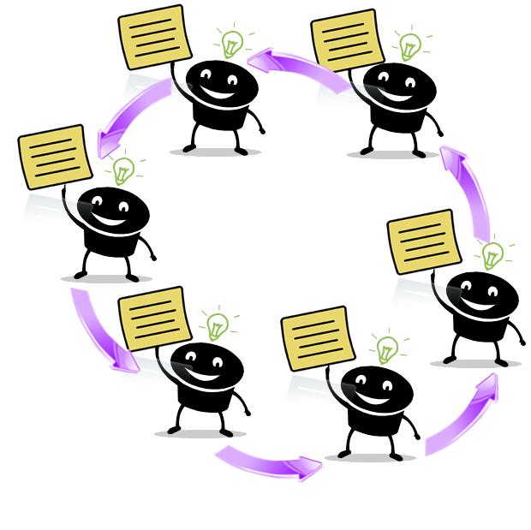
History:
Brainwriting is another technique of brainstorming. In 1969, Rohrbach proposed “Method 635” in which six people wrote three options on a worksheet that was then passed around the group five times. http://www.youtube.com/watch?v=TR1i1PPd8ZU

In 1979, Horst Geschka modified the tool and called it “Brainwriting Pool.” Studied by Gryskiewicz in 1980, it was found that it was most likely to stimulate options that focus on incremental change.

Brainwriting is an excellent way to give a group time to reflect on ideas and deliberately build on other thoughts.

Rules:
1. Focus the Group on the Task
- Write the task so it is visible to everyone.
- Have the client explain the task to the group.
- Have the client answer questions about the topic.
2. Distribute Supplies
- Give a Brainwriting worksheet to each participant, either on paper or with post-its. Have one extra sheet to place in the middle.
- Write the topic/problem statement at the top.

3. Review the Divergent Thinking Ground Rules http://www.youtube.com/watch?v=cjeJ60zQ8-E
- Rules: Defer Judgment; Strive for quantity; Seek Novelty – wild and unusual ideas; Combine and build to create other ideas – piggyback
- Clarify questions
4. Provide an Overview of Brainwriting (if concept is new to the group)
- Clarify the purpose and outcome of Brainwriting
- Overview the steps for the tool
- Set a target number of options to generate
- Answer questions about Brainwriting
5. Generate Options
- Silently think of three ideas and write each one in a separate box on the first row
- Pass your worksheet back to the center and pick up one that someone else has just finished
- Read the ideas on the new worksheet and build on them or come up with three new ideas
- If an option in the previous row does not trigger a new option, have group members write an entirely new option in the row
- Keep swapping worksheets until all the boxes are full. (Do not force them to finish)
6. Check on Progress
- Invite group members to share some interesting options from the worksheets
- Get feedback from the client. For example:
  - “Is this going in the right directions?”
  - “Is this working for you?”
- Determine if you need to continue with Brainwriting

7. Take Next Steps
- Generate additional options using the same or different tool

Tips:
- Review rules
- Establish guidelines for the group
- Use either a worksheet or large sheets with post-its
- Good for quiet or shy groups
- Actual number of ideas produced is higher because everyone is working simultaneously
- Promotes piggybacking

Applications:
- Clubs
- Classrooms: problem solving, writing – what makes a good character
- Generate ideas to solve problems
- Gives more time to students who need it to formulate their thoughts
- Time to think deeply
- Time to wrestle with a question which is new

